A000-AM,C-Taino-Pendant-Tripointer-Anthropomorphic-porphyritic rhyolite-1000 CE

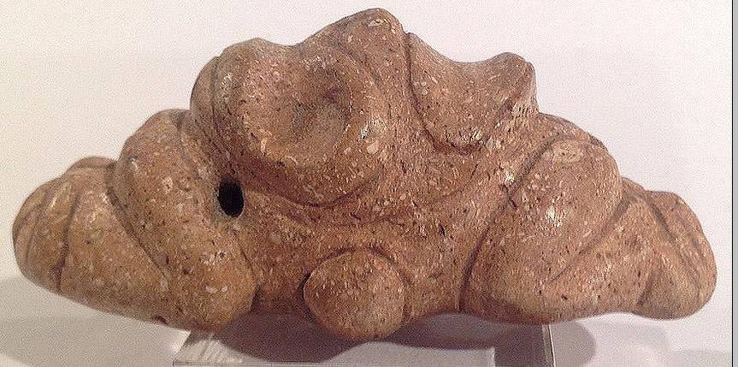 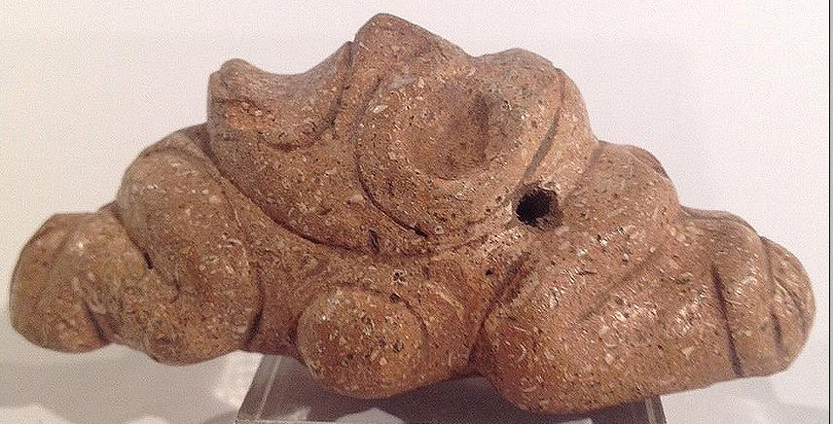

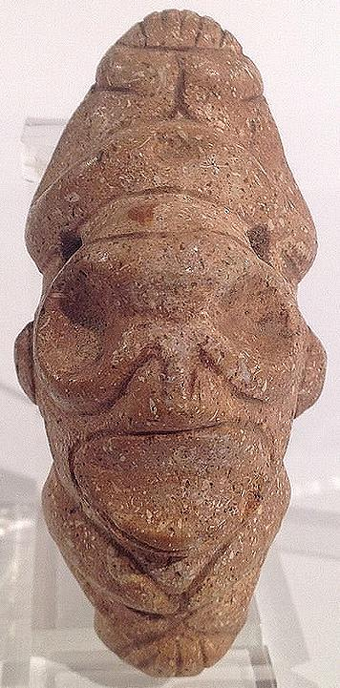 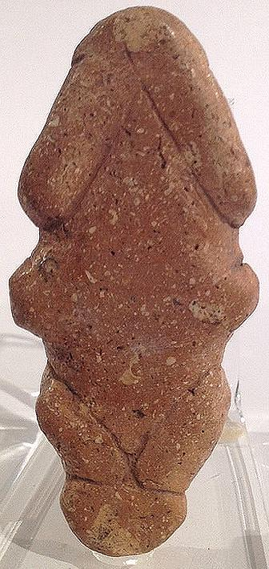

Figs. 1-4. AM,C-Taino-Pendant-Tripointer-Anthropomorphic-porphyritic rhyolite-1000 CE

.  
Dating c1000-1500AD.

Case No.: 17

**Accession No.**

**Formal Label:** AM,C-Taino-Pendant-Tripointer-Anthropomorphic-porphyritic rhyolite-1000 CE

**Display Description:**

Cemi made of porphyritic rhyolite this pendant is eell designed with suspension holes at top of head. Arms are overhead and legs bunch up under chin of disproportionate head. An unusual piece

**LC Classification:**

**Date or Time Horizon:**

**Geographical Area:** Originally from Hispaniola.

**Map:**

**GPS coordinates:**

**Cultural Affiliation:**

**Media:**

**Dimensions:** Measures 7.8 cm or 3".

**Weight:**

**Condition:**

**Provenance:** Originally from Hispaniola.

**Discussion:**

**References:**